Routledge Encyclopedia of Modernism

Submission by Geneva M. Gano, Antioch College

Image of author by [Edward Steichen](http://www.afterimagegallery.com/steichenWilla.htm)

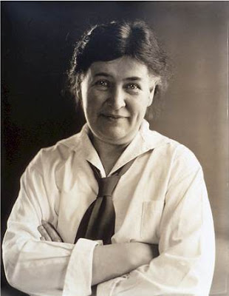

Cather, Willa Siebert (1873-1947)

Willa Cather was a major U.S. novelist active in the early twentieth century. Cather claimed a wide audience of admirers, including literary critics, writers and artists, and popular readers. Her relationship to modernism, however, is a contested one. Her reverence for the European masters of high culture, her tendency to look “backwards” rather than to the future, and her simple, “unfurnished” style distance her work philosophically and aesthetically from some of the most iconic modernist writers in the Western tradition. However, it must be remembered that modernism developed differentially across time and space; this insight allows us to see Cather as an important representative of the emergence of early modernism within the United States.

Though we often associate modernism with the metropolis, most of Cather’s twelve novels and many short stories depict the hardships facing rural folk: two of Cather’s early, best-known and best-loved works, *O Pioneers!* (1913) and *My Ántonia* (1918), as well as her Pulitzer Prize-winning novel *One of Ours* (1922), are set on farms in Cather’s home state of Nebraska. Cather’s unromantic depictions of rural life put her in “revolt from the village,” bringing her work into conversation with that of the early U.S. modernists Edgar Lee Masters, Sherwood Anderson, and Sinclair Lewis. Thematically, Cather’s works did not announce themselves as breaking radically with the past but rather contributed to an important emerging trend alongside those of her contemporaries.

Stylistically, Cather explicitly avoided what she called “bizarre invention” while at the same time experimenting with the structure of the modern novel. Cather described *O Pioneers!* as a weaving together of two distinct stories; she attempted a twist on this tactic in *The Professor’s House* (1925), in which she inserted a “nouvelle into the roman.”[1] *Death Comes for the Archbishop* (1927), too, was conceived of as an underdetermined episodic narrative “in the style of legend”: though a new approach to the novel, her method grew out of indications and examples from the pre-modern past. The hearkening to the deep past (and turn away from the superrational, superindustrial present and future) was a common impulse found in works by early U.S. modernists, as described by T.J. Jackson Lears.[2]

Culturally, Cather was at the heart of the emerging culture of U.S. modernism. Despite her rural, middle-class upbringing, Cather was a modern career woman who became educated, worked to support herself and her family as a journalist, and ultimately made the life-altering decision to quit her post as editor of *McClure’s Magazine* in 1911 to become a full-time author. Cather resided with her lifelong partner, Edith Lewis, in bohemian Greenwich Village, the heart of modernist activity in the U.S., where they were immersed in the revolutionary arts and culture percolating around them. Cather and Lewis were cosmopolitans who travelled domestically and abroad. They favored Paris in particular, where they participated in the international arts scene.

List of Works (abbreviated)

*O Pioneers!* (1913)

*My Ántonia* (1918)

*One of Ours* (1922)

*The Professor’s House* (1925)

*Death Comes for the Archbishop* (1927)

*Willa Cather on Writing* (1949)

References and Further Reading

[Willa Cather Archive](http://cather.unl.edu/)

James Woodress, Willa Cather: A Literary Life (Lincoln: university of Nebraska Press, 1987).

T.J. Jackson Lears, *No Place of Grace: Antimodernism and the Transformation of American Culture* (Chicago: University of Chicago Press, 1994).

1. Willa Cather, *Willa Cather on Writing* (Lincoln: University of Nebraska Press, 1988).
2. T.J. Jackson Lears, *No Place of Grace: Antimodernism and the Transformation of American Culture* (Chicago: University of Chicago Press, 1994).